**Bài tập kiểm thử và đảm bảo chất lượng phần mềm**

**Họ và tên: Vũ Văn Hậu**

**Mã sinh viên: 22021161**

**Link github: <https://github.com/vuhau190904/Testing-Assignment/tree/main/week%204>**

# **Bài 1:**

**Trình bày các bước trong quy trình kiểm thử dòng dữ liệu động:**

**Bước 1: Vẽ đồ thị luồng điều khiển CFG**

**Bước 2: Lựa chọn tiêu chí kiểm thử luồng dữ liệu**

**Bước 3: Xác định các đường đi trên CFG thoả mãn tiêu chí kiểm thử đã chọn**

**Bước 4: Sinh các ca kiểm thử tương ứng**

# **Bài 2:**

# **testingAssignment_week4-Page-1.drawio**

|  |  |  |
| --- | --- | --- |
|  | **X** | **Y** |
| **def** | 0, 4 | 0, 3 |
| **c-use** | 3, 5 | 3, 5 |
| **p-use** | 2 | 1 |

|  |  |  |
| --- | --- | --- |
| **Biến** | **du-pairs** | **def-clear path** |
| X | 0-2 | 0, 1(T), 2 |
| 0-3 | 0, 1(T), 2(T), 3 |
| 0-5 | 0, 1(T), 2(T), 3, 1(F), 5 |
| 4-2 | 4, 1(T), 2 |
| 4-3 | 4, 1(T), 2(T), 3 |
| 4-5 | 4, 1(F), 5 |
| Y | 0-1 | 0, 1 |
| 0-3 | 0, 1(T), 2(T), 3 |
| 0-5 | 0, 1(T), 2(F), 4, 1(F), 5 |
| 3-1 | 3, 1 |
| 3-3 | 3, 1(T), 2(T), 3 |
| 3-5 | 3, 1(T), 2(F), 4, 1(F), 5 |

|  |  |  |  |  |  |
| --- | --- | --- | --- | --- | --- |
| **Biến** | **du-pairs** | **def-clear path** | **complete path** | **Test case** | |
| **X** | **Y** |
| X | 0-2(T) | 0, 1(T), 2(T) | 0, 1(T), 2(T), 3, 1(F), 5 | 1 | 1 |
| 0-2(F) | 0, 1(T), 2(F) | x0, 1(T), 2(F), 4, 1(T), 2(T), 3, 1(F), 5 | -1, 1 | 1 |
| 0-3 | 0, 1(T), 2(T), 3 | 0, 1(T), 2(T), 3, 1(F), 5 | 1 | 1 |
| 0-5 | 0, 1(T), 2(T), 3, 1(F), 5 | 0, 1(T), 2(T), 3, 1(F), 5 | 1 | 1 |
| 4-2(T) | 4, 1(T), 2(T) | 0, 1(T), 2(F), 4, 1(T), 2(T), 3, 1(F), 5 | -1, 1 | 1 |
| 4-2(F) | 4, 1(T), 2(F) | 0, 1(T), 2(F), 4, 1(T), 2(F), 4, 1(T), 2(T), 3, 1(F), 5 | -1, -1, 1 | 1 |
| 4-3 | 4, 1(T), 2(T), 3 | 0, 1(T), 2(F), 4, 1(T), 2(T), 3, 1(F), 5 | -1, 1 | 1 |
| 4-5 | 4, 1(F), 5 | 0, 1(T), 2(F), 4, 1(T), 2(T), 3, 1(F), 5 | -1, 1 | 1 |
| Y | 0-1(T) | 0, 1(T) | 0, 1(T), 2(T), 3, 1(F), 5 | 1 | 1 |
| 0-1(F) | 0, 1(F) | 0, 1(F), 5 | -1 | -1 |
| 0-3 | 0, 1(T), 2(T), 3 | 0, 1(T), 2(T), 3, 1(F), 5 | 1 | 1 |
| 0-5 | 0, 1(T), 2(F), 4, 1(F), 5 | 0, 1(T), 2(F), 4, 1(T), 2(T), 3, 1(F), 5 | -1, 1 | 1 |
| 3-1(T) | 3, 1(T) | 0, 1(T), 2(T), 3, 1(T), 2(T), 3, 1(F), 5 | 1 | 2 |
| 3-1(F) | 3, 1(F) | 0, 1(T), 2(T), 3, 1(F), 5 | 1 | 1 |
| 3-3 | 3, 1(T), 2(T), 3 | 0, 1(T), 2(T), 3, 1(T), 2(T), 3, 1(F), 5 | 1 | 2 |
| 3-5 | 3, 1(F), 5 | 0, 1(T), 2(T), 3, 1(T), 2(T), 3, 1(F), 5 | 1 | 2 |

# Bài 3:

|  |  |  |  |
| --- | --- | --- | --- |
| Biến | Các câu lệnh def | Các câu lệnh c-use | Các câu lệnh p-use |
| n | * calFactiorial(int n) |  | * i <= n |
| result | * int result = 1 * result = result \* i | * result = result \* i |  |
| i | * int i = 1 | * result = result \* I * i++ | * i <= n |

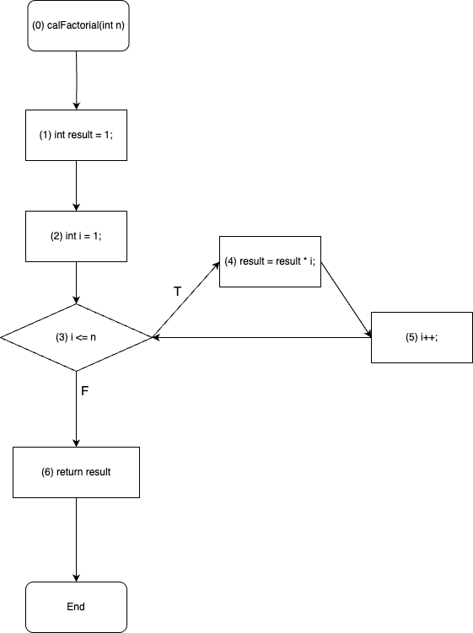

# Bài 4:

|  |  |  |
| --- | --- | --- |
|  | **X** | **Y** |
| **def** | 0, 3 | 0, 2, 5 |
| **c-use** | 3, 5 | 6 |
| **p-use** | 1, 4 | 1, 4 |

|  |  |  |
| --- | --- | --- |
| **Biến** | **def-clear path** | **du path** |
| X | * 0, 1 * 0, 1, 2 * 0, 1, 2, 4 * 0, 1, 2, 4, 5 * 0, 1, 2, 4, 6 * 0, 1, 2, 4, 5, 6 * 3, 4 * 3, 4, 5 * 3, 4, 6 * 3, 4, 5, 6 | * 0, 1 * 0, 1, 2, 4 * 0, 1, 2, 4, 5 * 3, 4 * 3, 4, 5 |
| Y | * 0, 1 * 0, 1, 3 * 0, 1, 3, 4 * 0, 1, 3, 4, 6 * 2, 4 * 2, 4, 6 * 5, 6 | * 0, 1 * 0, 1, 3, 4 * 0, 1, 3, 4, 6 * 2, 4 * 2, 4, 6 * 5, 6 |

**All p-uses/Some c-uses:**

|  |  |  |  |
| --- | --- | --- | --- |
| **Biến** | **du-pairs** | **def-clear path** | **complete path** |
| X | 0-1 | 0, 1 | 0, 1, 3, 4, 5, 6 |
| 0-4 | 0, 1, 2, 4 | 0, 1, 2, 4, 6 |
| 3-4 | 3, 4 | 0, 1, 3, 4, 5, 6 |
| Y | 0-1 | 0, 1 | 0, 1, 3, 4, 5, 6 |
| 0-4 | 0, 1, 3, 4 | 0, 1, 3, 4, 5, 6 |
| 2-4 | 2, 4 | 0, 1, 2, 4, 6 |
| 5-6 | 5, 6 | 0, 1, 3, 4, 5, 6 |

**All c-uses/Some p-uses:**

|  |  |  |  |
| --- | --- | --- | --- |
| **Biến** | **du-pairs** | **def-clear path** | **complete path** |
| X | 0-3 | 0, 1, 3 | 0, 1, 3, 4, 5, 6 |
| 0-5 | 0, 1, 2, 4, 5 | 0, 1, 2, 4, 5, 6 |
| 3-5 | 3, 4, 5 | 0, 1, 3, 4, 5, 6 |
| Y | 0-6 | 0, 1, 3, 4, 6 | 0, 1, 3, 4, 6 |
| 2-6 | 0, 1, 2, 4, 6 | 0, 1, 2, 4, 6 |
| 5-6 | 5, 6 | 0, 1, 3, 4, 5, 6 |

**Biểu thức của các p-use(x,y) tại cạnh (1,3) và (4,5) lần lượt là x+y = 4 và**

**x2+y2 > 17. Đường đi (0-1-3-4-5-6) có thực thi được vì:**

Theo bất đẳng thức cosin:

x2 + y2 > 2xy

2 \* ( x2 + y2 )> x2 + y2 + 2xy

2 \* ( x2 + y2 )> (x + y)2

2 \* ( x2 + y2 )> (4)2 = 16

Mà x2 + y2 > 17 => 2 \* ( x2 + y2 )> 34

=> Hệ trên luôn có nghiệm

**Đỉnh 3 không tồn tại mối quan hệ def-use vì không tồn tại 1 def-clear path của 1 cặp du pair nào tại đỉnh 3 có độ dài lớn hơn 1 (do định nghĩa)**

# Bài 5:

# testingAssignment_week4-Page-3.drawio

|  |  |  |  |
| --- | --- | --- | --- |
| Kiểm thử với độ đo C2 | | | |
| STT | Test Path | Test cases | |
| m | n |
| 1 | 0, 1(T), 2, 3(T), 4, 5(F), 7(F), 9(T), 10(F), 12, 9(T), 10(T), 11, 9(F), 8 | -2 | -3 |
| 2 | 0, 1(F), 3(F), 5(T) | 0 | 1 |
| 3 | 0, 1(F), 3(F), 5(F), 7(T) | 1 | 0 |

|  |  |  |
| --- | --- | --- |
|  | **m** | **n** |
| **def** | 0, 2, 11 | 0, 4, 12 |
| **c-use** | 2, 11, 12 | 4, 11, 12 |
| **p-use** | 1, 5, 9, 10 | 3, 7, 9, 10 |

**All def coverage:**

|  |  |  |  |  |  |
| --- | --- | --- | --- | --- | --- |
| **Biến** | **du-pairs** | **def-clear path** | **complete path** | **Test cases** | |
| m | n |
| m | 0-2 | 0, 1(T), 2 | 0, 1(T), 2, 3(T), 4, 5(F), 7(F), 9(T), 10(F), 12, 9(T), 10(T), 11, 9(F), 8 | -2 | -3 |
| 2-9 | 2, 3(T), 4, 5(F), 7(F), 9 | 0, 1(T), 2, 3(T), 4, 5(F), 7(F), 9(T), 10(F), 12, 9(T), 10(T), 11, 9(F), 8 | -2 | -3 |
| 11-9 | 11, 9 | 0, 1(T), 2, 3(T), 4, 5(F), 7(F), 9(T), 10(F), 12, 9(T), 10(T), 11, 9(F), 8 | -2 | -3 |
| n | 0-3 | 0, 1(F), 3 | 0, 1(T), 2, 3(T), 4, 5(F), 7(F), 9(T), 10(F), 12, 9(T), 10(T), 11, 9(F), 8 | -2 | -3 |
| 4-7 | 4, 5(F), 7 | 0, 1(T), 2, 3(T), 4, 5(F), 7(F), 9(T), 10(F), 12, 9(T), 10(T), 11, 9(F), 8 | -2 | -3 |
| 12-9 | 12, 9 | 0, 1(T), 2, 3(T), 4, 5(F), 7(F), 9(T), 10(F), 12, 9(T), 10(T), 11, 9(F), 8 | -2 | -3 |

# Bài 6:

## Đặc tả

Xét hàm result trả về phân loại kết quả học tập của sinh viên trong 1 môn học của Trường Đại Học Công Nghệ

## Đầu vào

|  |  |  |
| --- | --- | --- |
| Input | Kiểu dữ liệu | Miền hợp lệ |
| participation | Số nguyên | Từ 0 đến 100 |
| assignment | Số nguyên | Từ 0 đến 100 |
| midterm | Số nguyên | Từ 0 đến 100 |
| final | Số nguyên | Từ 0 đến 100 |

**Đầu ra**

Đầu ra thuộc một trong các giá trị sau:

- ”Đầu vào không hợp lệ”

- “A+”

- “A”

- “B+”

- “B”

- “C+”

- “C”

- “D+”

- “D”

- “F”

## Mối quan hệ giữa đầu vào và đầu ra

Xét giá trị average = 0.2\*assignments + 0.1\*participation +0.3\*midterm + 0.4\*final

trong đó 0 <= participation, assignment, midterm, final <= 100

Khi đó quan hệ giữa đầu vào và đầu ra của bài toán như sau:

|  |  |
| --- | --- |
| Đầu vào | Đầu ra |
| participation, assignment, midterm, final không thuộc miền hợp lệ | Đầu vào không hợp lệ |
| average < 40 | F |
| 40 <= average < 50 | D |
| 50 <= average < 55 | D+ |
| 55 <= average < 65 | C |
| 65 <= average < 70 | C+ |
| 70 <= average < 80 | B |
| 80 <= average < 85 | B+ |
| 85 <= average < 90 | A |
| 90 <= average <= 100 | A+ |

## Mã nguồn bài toán

Mã nguồn C++ của chương trình có ở hình dưới. Một số dòng dòng có chứa bug, các này đã được comment:

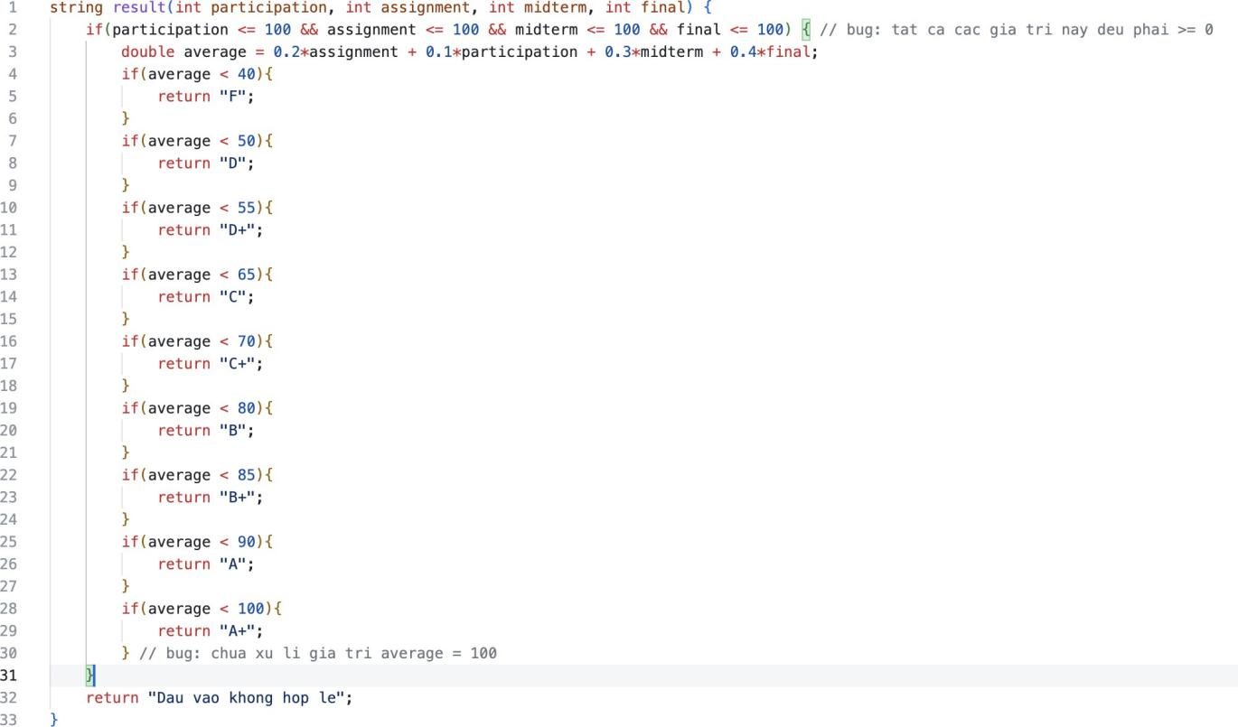

# CTF và Test Cases

# testingAssignment-Page-4.drawio

|  |  |  |  |  |  |
| --- | --- | --- | --- | --- | --- |
|  | assignments | participation | midterm | final | average |
| **def** | 0 | 0 | 0 | 0 | 3 |
| **c-use** | 3 | 3 | 3 | 3 | 4, 6, 8, 10, 12, 14, 16, 18, 20 |
| **p-use** | 1 | 1 | 1 | 1 |  |

|  |  |  |  |  |  |  |  |
| --- | --- | --- | --- | --- | --- | --- | --- |
| **Biến** | **du-pairs** | **def-clear path** | **complete path** | **Test cases** | | | |
| assignments | participation | midterm | final |
| assignments | 0-3 | 0, 1(T), 3 | 0, 1(T), 3, 4(F), 6(F), 8(F), 10(F), 12(F), 14(F), 16(F), 18(F), 20(T), 21 | 95 | 90 | 93 | 96 |
| 0-1(T) | 0, 1(T) | 0, 1(T), 3, 4(F), 6(F), 8(F), 10(F), 12(F), 14(F), 16(F), 18(F), 20(T), 21 | 95 | 90 | 93 | 96 |
| 0-1(F) | 0, 1(F), 2 | 0, 1(F), 2 | 95 | 90 | 93 | 96 |
| participation | 0-3 | 0, 1(T), 3 | 0, 1(T), 3, 4(F), 6(F), 8(F), 10(F), 12(F), 14(F), 16(F), 18(F), 20(T), 21 | 95 | 90 | 93 | 96 |
| 0-1(T) | 0, 1(T) | 0, 1(T), 3, 4(F), 6(F), 8(F), 10(F), 12(F), 14(F), 16(F), 18(F), 20(T), 21 | 95 | 90 | 93 | 96 |
| 0-1(F) | 0, 1(F), 2 | 0, 1(F), 2 | 95 | 90 | 93 | 96 |
| midterm | 0-3 | 0, 1(T), 3 | 0, 1(T), 3, 4(F), 6(F), 8(F), 10(F), 12(F), 14(F), 16(F), 18(F), 20(T), 21 | 95 | 90 | 93 | 96 |
| 0-1(T) | 0, 1(T) | 0, 1(T), 3, 4(F), 6(F), 8(F), 10(F), 12(F), 14(F), 16(F), 18(F), 20(T), 21 | 95 | 90 | 93 | 96 |
| 0-1(F) | 0, 1(F), 2 | 0, 1(F), 2 | 95 | 90 | 93 | 96 |
| final | 0-3 | 0, 1(T), 3 | 0, 1(T), 3, 4(F), 6(F), 8(F), 10(F), 12(F), 14(F), 16(F), 18(F), 20(T), 21 | 95 | 90 | 93 | 96 |
| 0-1(T) | 0, 1(T) | 0, 1(T), 3, 4(F), 6(F), 8(F), 10(F), 12(F), 14(F), 16(F), 18(F), 20(T), 21 | 95 | 90 | 93 | 96 |
| 0-1(F) | 0, 1(F), 2 | 0, 1(F), 2 | 95 | 90 | 93 | 96 |
| average | 3-4 | 3, 4 | 0, 1(T), 3, 4(F), 6(F), 8(F), 10(F), 12(F), 14(F), 16(F), 18(F), 20(T), 21 | 95 | 90 | 93 | 96 |
| 3-6 | 3, 4(F), 6 | 0, 1(T), 3, 4(F), 6(F), 8(F), 10(F), 12(F), 14(F), 16(F), 18(F), 20(T), 21 | 95 | 90 | 93 | 96 |
| 3-8 | 3, 4(F), 6(F), 8 | 0, 1(T), 3, 4(F), 6(F), 8(F), 10(F), 12(F), 14(F), 16(F), 18(F), 20(T), 21 | 95 | 90 | 93 | 96 |
| 3-10 | 3, 4(F), 6(F), 8(F), 10 | 0, 1(T), 3, 4(F), 6(F), 8(F), 10(F), 12(F), 14(F), 16(F), 18(F), 20(T), 21 | 95 | 90 | 93 | 96 |
| 3-12 | 3, 4(F), 6(F), 8(F), 10(F), 12 | 0, 1(T), 3, 4(F), 6(F), 8(F), 10(F), 12(F), 14(F), 16(F), 18(F), 20(T), 21 | 95 | 90 | 93 | 96 |
| 3-14 | 3, 4(F), 6(F), 8(F), 10(F), 12(F), 14 | 0, 1(T), 3, 4(F), 6(F), 8(F), 10(F), 12(F), 14(F), 16(F), 18(F), 20(T), 21 | 95 | 90 | 93 | 96 |
| 3-16 | 3, 4(F), 6(F), 8(F), 10(F), 12(F), 14(F), 16 | 0, 1(T), 3, 4(F), 6(F), 8(F), 10(F), 12(F), 14(F), 16(F), 18(F), 20(T), 21 | 95 | 90 | 93 | 96 |
| 3-18 | 3, 4(F), 6(F), 8(F), 10(F), 12(F), 14(F), 16(F), 18 | 0, 1(T), 3, 4(F), 6(F), 8(F), 10(F), 12(F), 14(F), 16(F), 18(F), 20(T), 21 | 95 | 90 | 93 | 96 |
| 3-20 | 3, 4(F), 6(F), 8(F), 10(F), 12(F), 14(F), 16(F), 18(F), 20 | 0, 1(T), 3, 4(F), 6(F), 8(F), 10(F), 12(F), 14(F), 16(F), 18(F), 20(T), 21 | 95 | 90 | 93 | 96 |